Questions:

- What is cloud computing?
- Type of cloud computing.
- What is DevOps?
- What is DevSecOps?
- What is waterfall model in DevOps?
- Top 10 IT companies in India and how to reach them for job openings?
- Apply by using the IT companies portal: https://career.infosys.com/
- Main cloud service provider.
Azure
- What is Azure Cloud?
- How to create a free account on Azure?
- Create a new account on Gmail
- Go to Azure portal http://portal.azure.com/
- How to create resource group on Azure?
- How to create users on Azure? (invite/create)
- How to provide access to different users?
- How to provide owner access to a particular user on perticule subscription?
- How to create groups on Azure and add users to it?
- How to provide access to particular group to perticule subscription?
- What is extension on VM and how to add it?
Go on Azure Portal → select VM → select Extensions + applications → Add → select extension → Next → create
- What is a tag and how to apply tag on Azure resources?
- What is VM and how to create VM on Azure cloud?
- How to access Linux and Windows Azure VMs?
- How to create a user in VM and reset passwords for old users?
- What is Azure alerts and how to apply it on VMs?
- What is Bastion server and how to access VMs using Bastion?
Azure Portal → VM → Bastion → Deploy Bastion → Now go to Bastion and put the username and password → connect
- Install and configure Apache on Linux VM.
- What is Azure Monitoring and how to check it for VM?
- How to create IIS and deploy a website on it?
- Use of SCP command
- How to increase the VM size and disk size?
- How to add additional data disk on VM?
- What is Azure recovery service vault and how to create it?
- How to take backup and configure backup on Azure VM?
- How to restore the VM using backup? Need to do
- Access the VM on Portal → Backup → Restore VM → Restore point → select → select the restore point (anyone) → ok
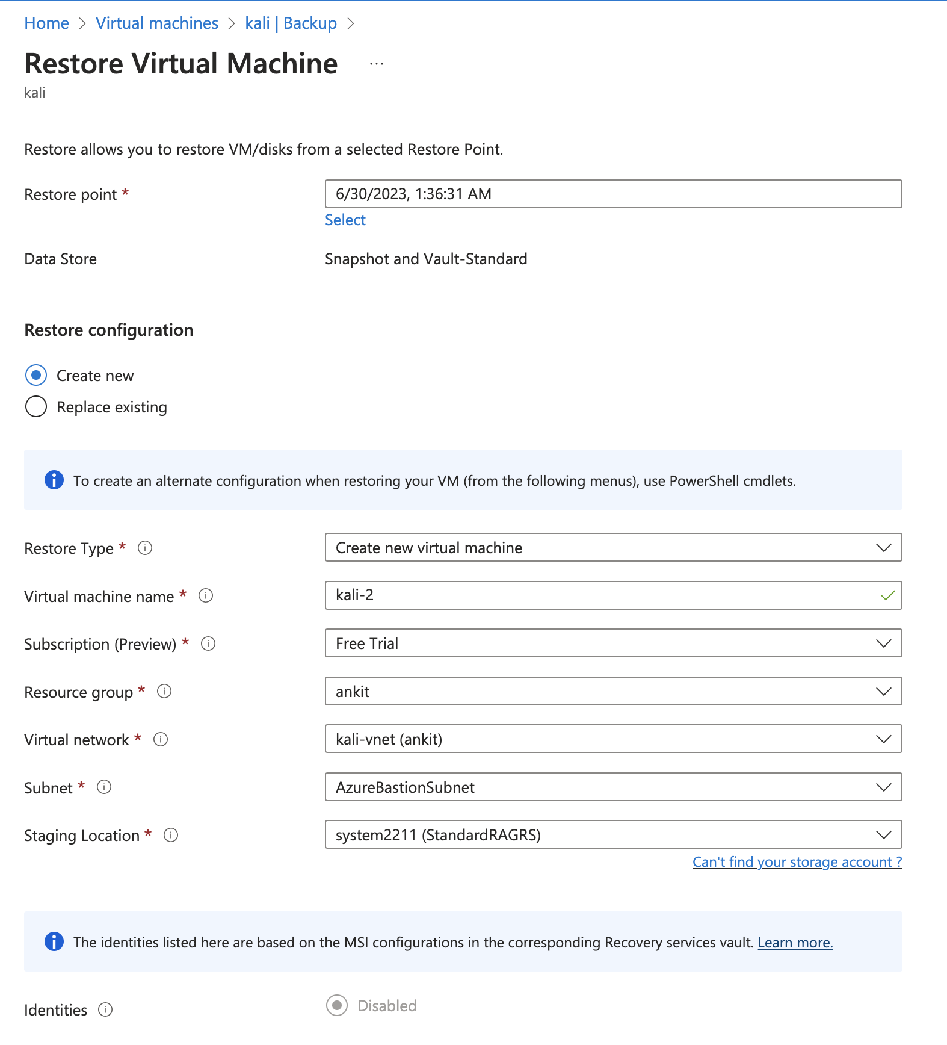
-
- What is Storage account and how to create storage account on Azure?
- How to upload data on Azure storage.
- How to access storage content publicly by URL in Azure?
- How to create AppService Plan on Azure?
- How to create AppService (WebApp) on Azure and deploy code on it using windows?
- How to create AppService (WebApp) on Azure and deploy code on it using linux?
- What is kudu console and how to access it?
- How to create an account on Godaddy and buy a domain?
- How to apply Locks on resources?
- How to access VM using Guest access? Need to do
- How to access a VM using SSH key? Need to do
- Virtual Machine Scale Sets (VMSS)? Need to do
- What is Microsoft Defender?
- What is serial console in VM and how to access it?
https://learn.microsoft.com/en-gb/troubleshoot/azure/virtual-machines/serial-console-linux
- What is boot diagnosis in VM and how to access it?
- Database → MSSQL

Next class tasks:

- Create an account in https://career.infosys.com/

- How to create IIS and deploy a website on it?
- Create a VM using Windows Server OS
- Access the VM using RDP
- Open the server manager console
- Click on → Add role → next → next → next
- select web server IIS → add feature → next → next → next → Install
- Once installation is completed → now configure the IIS
- Now go on search → type IIS → select the IIS Manager → double click on VM name → click on sites → click on default site → and test it
- Now we need to copy our website code inside the IIS → for this open This PC → c: → inetpub → wwwroot → delete the existing data → paste the website code → and go inside the IIS and check the website in local machine (using localhost)
- Now copy the public IP of VM and open it in any browser (error)
- To solve this issue → go inside the VM → networking → add port 80 to allow HTTP
- Now refresh the Website or hit the public IP again

GitHub:

- Create an account on Github.
- Google → Github → Sign up
- Create a repository on GitHub. And understand the types of it.
- Try to create public and private repos.
- How to provide access on Private repos?
- What is branches in GitHub?
- What is the default branch in GitHub?
- Once repo and branch is created, how to upload website code?
- We can upload the code by drag and drop
- Download and install GitHub Desktop Application on your local system and use it to upload the code.
- Login to Desktop application by your Github credentials
- How to clone Github Repo in my local system using Dekstop Application. → Download and install Github
→ Login using Github access
→ Click on Clone
→ select the repo
→ click on clone
- How to clone Github repo in my local system.
- How to create a repo using Desktop Github Application.
- Open the Gihub application
- Click on aero
- click on add
- click on create new repo → fill the inforamtion
- click on pulish repo
- again click on pulish repo
- How to commit changes in GitHub repos?
- Repo must be clone
- Edit any file (index.html)
- on go on desktop application
- give any comment
- click on commit
- click on push
- now go on GitHub portal and check the data (you can also check the changes committed using commit option)
- How to create a new branch?
- Go on Gihub portal
- click on current branch drop and down
- type the new branch name
- click on create branch
- How to track changes from 2 different branches?
- You just have to go on GitHub portal → select the branch → it will show you the details with other branches
- How to implement lock or security on branches (main) to protect it?
- go inside the repo
- click on setting
- click on branches
- click on add branch protection rule or Add rule
- type the branch name
- click on Lock branch
- click on create
- What is Enterprise account on GitHub?
Your enterprise account on GitHub.com allows you to manage multiple organizations. Your enterprise account must have a handle, like an organization or user account on GitHub. Organizations are shared accounts where enterprise members can collaborate across many projects at once.
- How to find the issue or bugs in code on GitHub?
Will cover later
- How to create a PR on Github:
- PR stand for Pull Request
Will cover later

Website issue

AWS

Login Portal URL: https://console.aws.amazon.com/
Root User
Username: jetkingy@gmail.com
Password: 12345678-asdF

- How to create EC2 Instance (VM) on AWS?
- Login to AWS portal → search → ec2 → select ec2 → this will display EC2 dashboard
- Select Region → Launch Instance → Name → OS Image → select verision → select instance type → go on Key pair → select the existing key (if not then generate a key pair) → create new key pait → network setting → define proper setting → storage → create
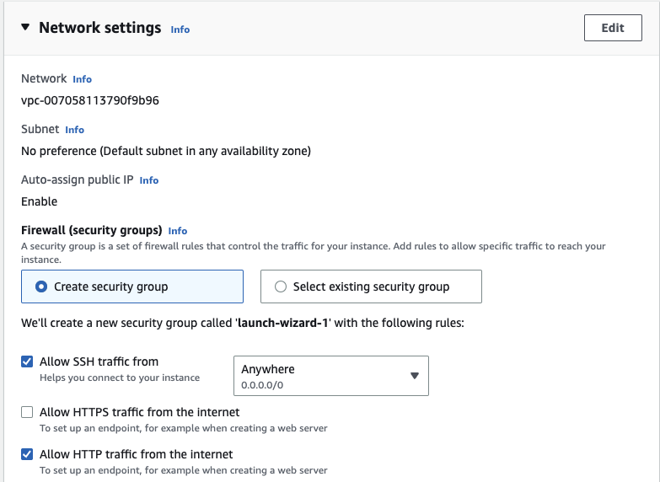

- How to connect with EC2 instance?
→ There are generally multiple ways to connect with EC2:
- EC2 instance connect
- SSH client
-
- What is S3 Bucket (Storage) in AWS?
- How to create S3 Bucket?
- Search for S3
- click on create bucket
-
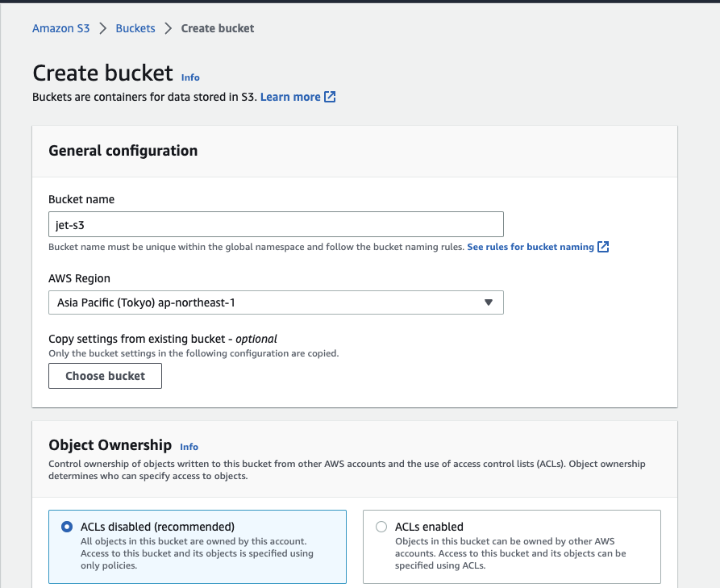
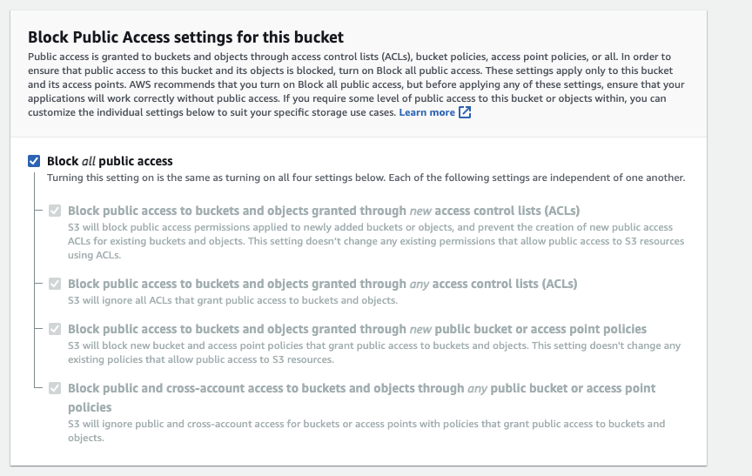
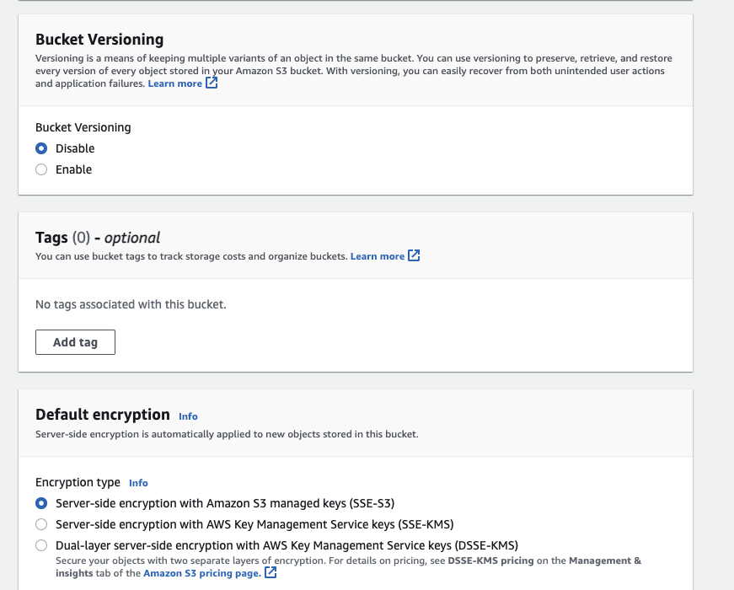
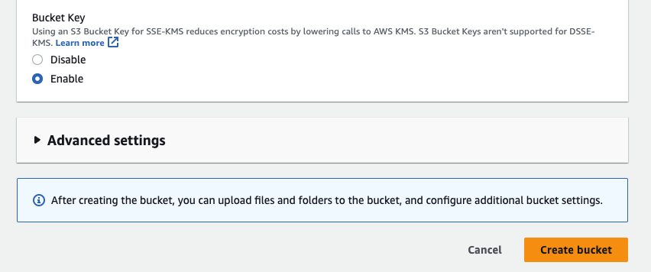
- How to upload object in S3?
- How to access S3 bucket publicly?
- Create a bucket with private access
- select that bucket
- permission
- Block public access → edit → uncheck (Block all public access) → save changes → confirm → confirm
- Bucket policy → edit → policy generator →
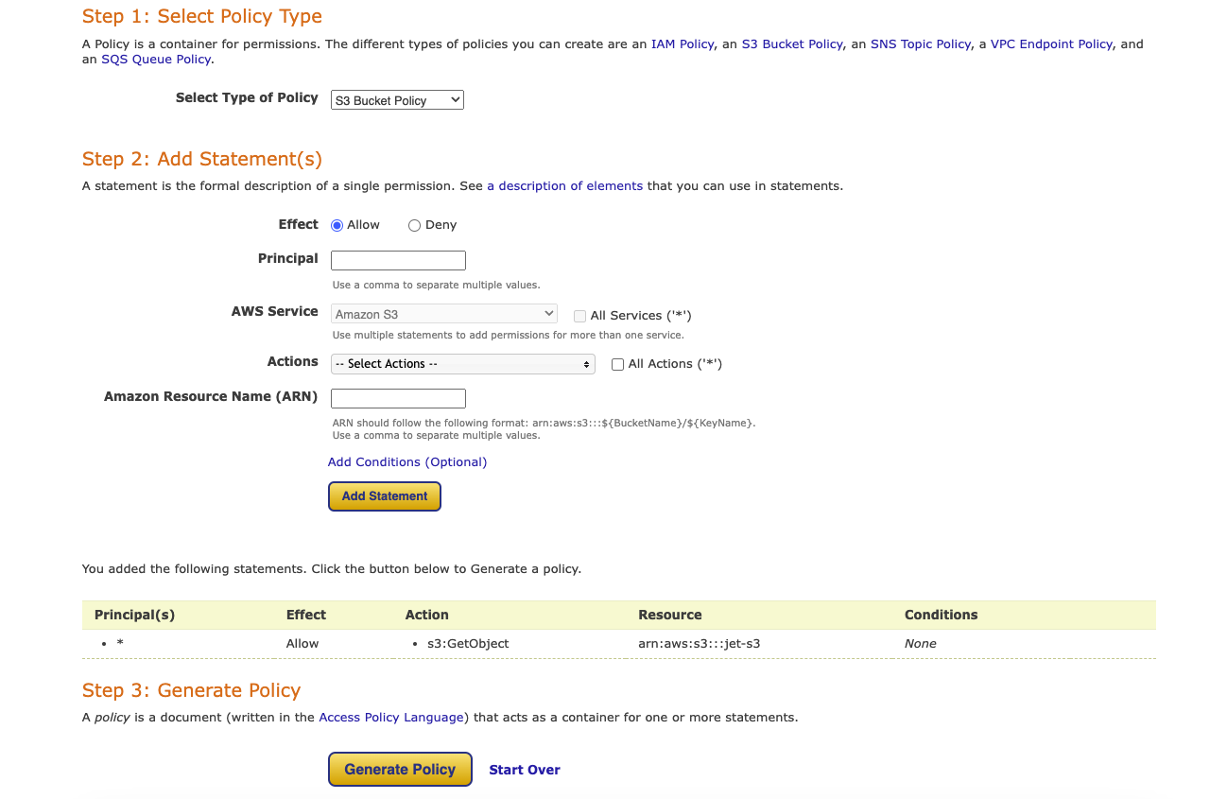
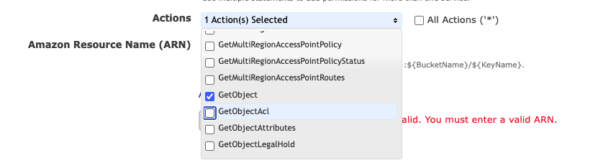
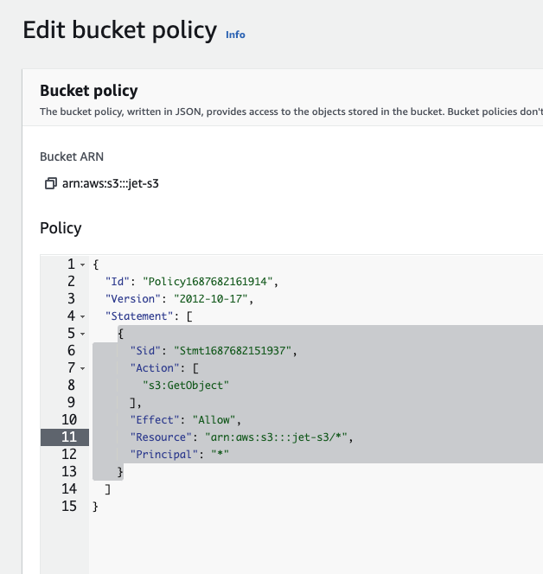
- How to deploy static website on S3 Bucket?
- select bucket
- select properties
- enable static website
- index.html
- save
- upload the data in s3 bucket

